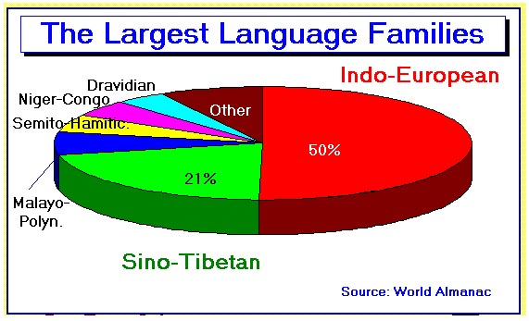
Introduction The Indo/European Language Hist/Myth
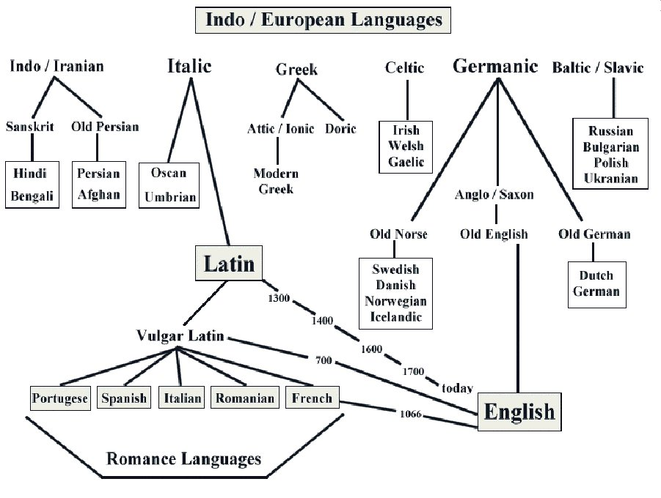
Introduction Language Chart Hist/Myth

Introduction Cognates Hist/Myth

Indo/European Language Cognates

INDO-EUROPEAN LANGUAGES

English  Welsh  Irish  French  Spanish  Portuguese  Italian  Latin  German  Dutch  Icelandic  Swedish  Polish  Romanian  Albanian  Greek  Russian  Lithuanian  Armenian  Persian  Sanskrit | month  mis  mí  mois  mes  mês  mese  mensis  Monat  maand  mánuður  månad  miesiac  luna  muaj  men  mesyats  ménuo  amis  mah  mas | mother  mam  máthair  mère  madre  mâe  madre  mater  Mutter  moeder  móðir  moder  matka  mama  nënë  meter  mat'  motina  mayr  madar  matar | new  newydd  nua  nouveau  nuevo  novo  nuovo  novus  neu  nieuw  nýr  ny  nowy  nou  i ri  neos  novy  naujas  nor  nau  nava | night  nos  oíche  nuit  noche  noitre  notte  nox  Nacht  nacht  nótt  natt  noc  noapte  natë  nux  noch'  naktis  kisher  shab  nakt | nose  trwyn  srón  nez  nariz  nariz  naso  nasus  Nase  neus  nef  näsa  nos  nas  hundë  rhis  nos  nosis  kit  bini  nas | three  tri  trí  trois  tres  três  tre  tres  drei  drei  þrír  tre  trzy  trei  tre, tri  treis  tri  trys  yerek  se  trayas

NON-INDO-EUROPEAN LANGUAGES

Basque  Finnish  Hungarian  Turkish  English | hilabethe  kuukausi  hónap  ay  month | ama  äiti  anya  anne  mother | berri  uusi  új  yeni  new | gai  yö  éjszaka  gece  night | südür  nenä  orr  burun  nose | hirur  kolme  három  üç  three

Introduction Derivatives Hist/Myth

English Latin Cognate English Derivative

mother mater maternal
two duo duet
tooth dens, dentis dental
foot pes, pedis pedestrian
brother frater fraternal
old senis senile
son filius filial
soldier miles, militis military
moon luna lunar

sister soror sorority

bold audax audacious

law lex, legis legal

audio audition

remaneo remain

donum donation

lumen illuminate

multus multiply

Introduction Hist/Myth

History of Language Study Guide

Indo / European __________________________________________
__________________________________________
__________________________________________
__________________________________________
__________________________________________

Caucasus Mts. __________________________________________
__________________________________________
__________________________________________
__________________________________________

Italic __________________________________________
__________________________________________
__________________________________________
__________________________________________
__________________________________________

Germanic __________________________________________
__________________________________________
__________________________________________
__________________________________________

Indo / Iranian __________________________________________
__________________________________________
__________________________________________
__________________________________________

Celtic __________________________________________
__________________________________________
__________________________________________
_________________________________________

Attic / Ionic __________________________________________
__________________________________________
__________________________________________

Latin __________________________________________
__________________________________________
__________________________________________
__________________________________________
__________________________________________
__________________________________________

Vulgar Latin __________________________________________
__________________________________________
__________________________________________
__________________________________________
__________________________________________

Romance Languages _______________________________________
__________________________________________
__________________________________________
__________________________________________
__________________________________________

Derivative __________________________________________
__________________________________________
__________________________________________
__________________________________________
__________________________________________

Cognate __________________________________________
__________________________________________
__________________________________________
__________________________________________
__________________________________________

